**THE PEARL EXAMINATION 2024**

**TERM II QUALITY ASSURANCE**

**BABY CLASS: (3 – 4 YEARS)**

**LEARNING AREA 4: MATHEMATICAL CONCEPTS**

**My name is: ………………………………..………………..……………….**

**My School is: ……………………………..……….………..………………..**

**I am in: ………………………………..…………………………………………………..**

1. **Name the shapes orally.**
2. **Colour number I.**
3. **Match these shapes.**
4. 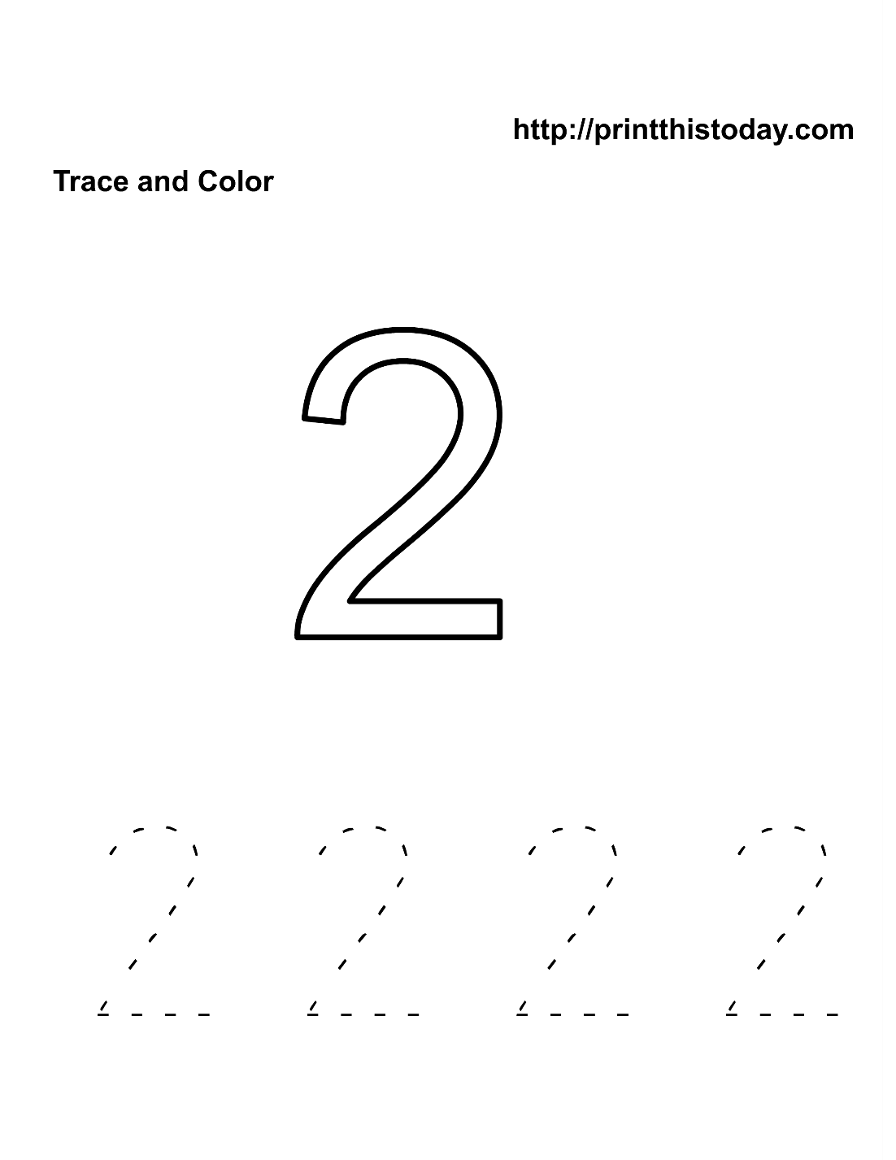**Write over these numbers.**

1. **Match the same numbers.**

0 5

1 4

2 0

3 1

4 2

5 3

**END**